Begin brainstorming and decomposing your project in terms of major systems/components;

1. What is the overall challenge, what are the sub-challenges/parts
   1. Proving closure properties on operations from file A to file B
2. What infrastructure will you need to support the whole project as well as sub-components
   1. Android Studio
      1. Java / Kotlin
      2. Git
   2. Android Device
   3. Google Play Store
3. Create first pass Top-Level and Lower-Level System Diagrams

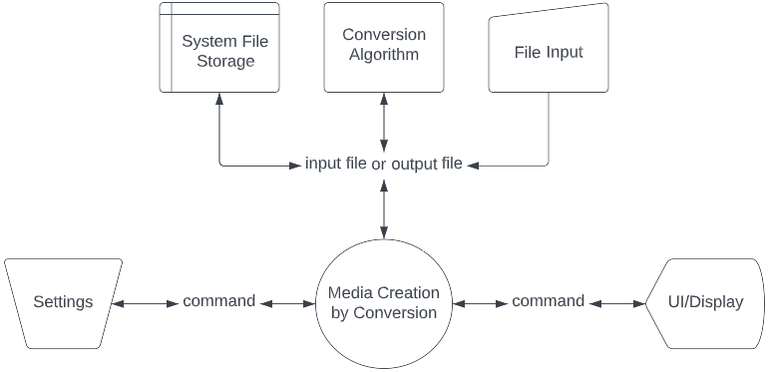

1. Bonus: Sketch out the start of Use Case Diagrams

